**Moez Ahsan Azam**

**Code:**

import os

import cv2

import numpy as np

import cv2

import numpy as np

def find_optic_disk(image_path, min_radius=20, max_radius=60):

    img = cv2.imread(image_path)

    if img is None:

        raise ValueError(f"Could not read image at {image_path}")

    resized_img = cv2.resize(img, (720, 720))

    gray_img = cv2.cvtColor(resized_img, cv2.COLOR_BGR2GRAY)

    blurred_img = cv2.GaussianBlur(gray_img, (15, 15), 0)

    _, thresh = cv2.threshold(blurred_img, 200, 255, cv2.THRESH_BINARY)

    contours, _ = cv2.findContours(thresh, cv2.RETR_EXTERNAL, cv2.CHAIN_APPROX_SIMPLE)

    optic_disc_contour = None

    largest_area = 0

    optic_disc_center = None

    for contour in contours:

        area = cv2.contourArea(contour)

        (x, y), radius = cv2.minEnclosingCircle(contour)

        if min_radius <= radius <= max_radius and area > largest_area:

            largest_area = area

            optic_disc_contour = contour

            optic_disc_center = (int(x), int(y))

    if optic_disc_contour is not None:

        (x, y), radius = cv2.minEnclosingCircle(optic_disc_contour)

        cv2.circle(resized_img, (int(x), int(y)), int(radius), (0, 255, 0), 3)

    return resized_img, optic_disc_center

def find_optic_disk(image_path, roi_size=(110, 110)):

    img = cv2.imread(image_path)

    if img is None:

        raise ValueError(f"Could not read image at {image_path}")

    resized_img = cv2.resize(img, (720, 720))

    blurred_img = cv2.GaussianBlur(resized_img, (49, 49), 0)

    kernel = np.ones((3, 3), np.uint8)

    opened_img = cv2.morphologyEx(blurred_img, cv2.MORPH_OPEN, kernel)

    gray_img = cv2.cvtColor(opened_img, cv2.COLOR_BGR2GRAY)

    _, _, _, max_loc = cv2.minMaxLoc(gray_img)

    top_left_x = max(0, max_loc[0] - roi_size[0] // 2)

    top_left_y = max(0, max_loc[1] - roi_size[1] // 2)

    bottom_right_x = min(resized_img.shape[1], top_left_x + roi_size[0])

    bottom_right_y = min(resized_img.shape[0], top_left_y + roi_size[1])

    color = (0, 255, 0)

    thickness = 2

    cv2.rectangle(resized_img, (top_left_x, top_left_y), (bottom_right_x, bottom_right_y), color, thickness)

    return resized_img

image_folder = "Fundus_image"

image_extensions = ["tif", "jpg", "jpeg"]

for i in range(1, 20):

    image_file = None

    for ext in image_extensions:

        temp_image_file = f"{i}.{ext}"

        image_path = os.path.join(image_folder, temp_image_file)

        if os.path.exists(image_path):

            image_file = temp_image_file

            break

    if not image_file:

        print(f"No valid image found for index {i}")

        continue

    image_path = os.path.join(image_folder, image_file)

    img = cv2.imread(image_path)

    if img is None:

        print(f"Failed to read image: {image_file}")

        continue

    try:

        roi = mark_brightest_region(image_path)

        img1,cord = find_optic_disk (image_path)

        print(cord)

        cv2.imshow("ROI Image",roi)

        cv2.imshow("Image",img1)

        cv2.waitKey(0)

        print(f"Successfully processed image: {image_file}")

    except Exception as e:

        print(f"Error processing {image_file}: {e}")

**Output:**

**Examples of some output:**

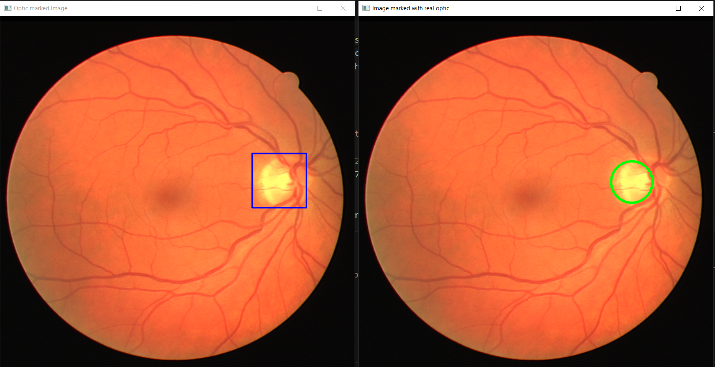

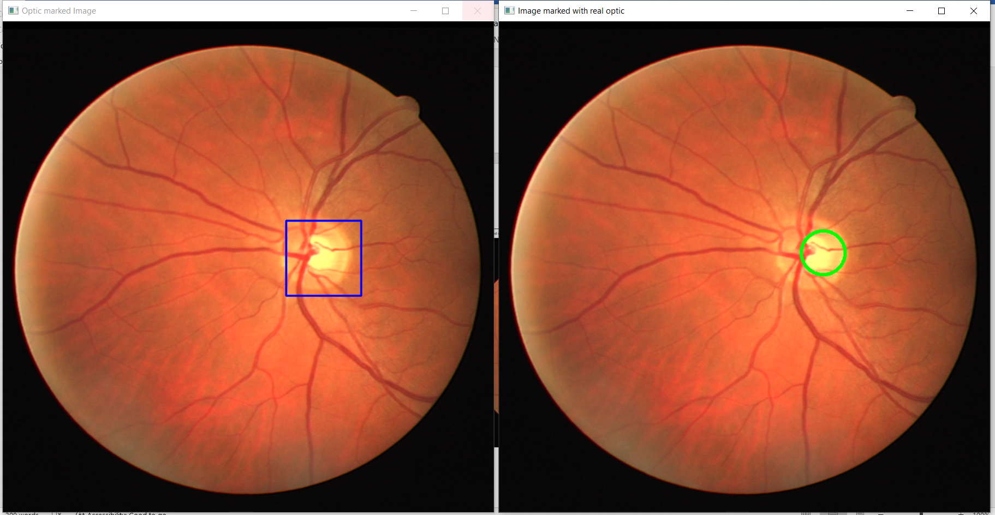

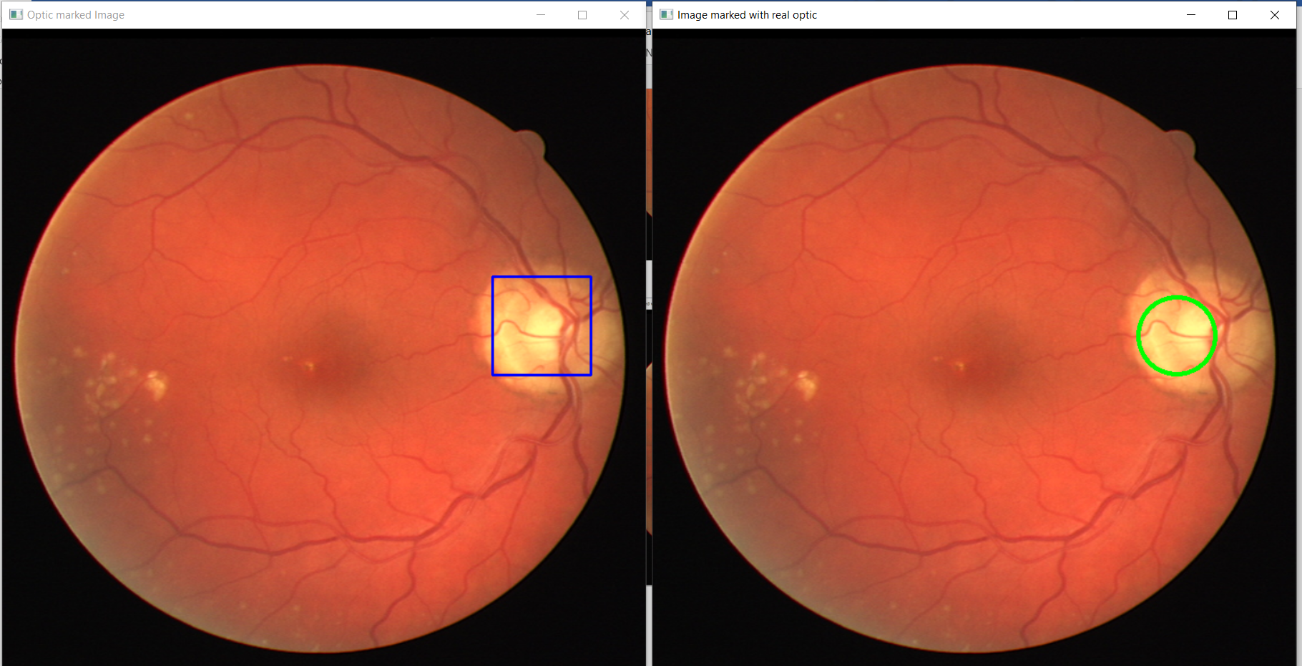

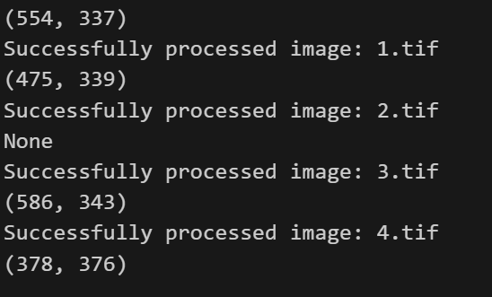

**Pseudo Code:**

* Open and read the image from the given location. If it can't be read, show an error message.
* Adjust the image to a common size to keep things consistent.
* Change the image to black and white.
* Apply a blur effect to smooth out any noise or small details.
* Use a technique to turn the image into just black and white, where white represents the brightest areas.
* I have used opening and guassian filter to remove noise.
* Look for the outlines of the bright shapes in the image.
* Among the shapes you found, locate the one that could be the optic disc based on its size and shape.
* If we find it, get its center point and radius to mark it.
* Draw a circle where the real optic disc is located.
* Try to process each image to identify the optic disc and the brightest region.
* Display the images with the marked optic disc and brightest region.